Hydra Publications novels@hydrapublications.com
337 Clifty Drive hydrapublications.com | 812.574.4113
Madison, IN 47250

Contact: Hydra Publications, Marketing Director
marketing@hydrapublications.com

for immediate release

The Jealousy Glass
Volume Two of the Artifacts of Empire fantasy series
Gwen Perkins
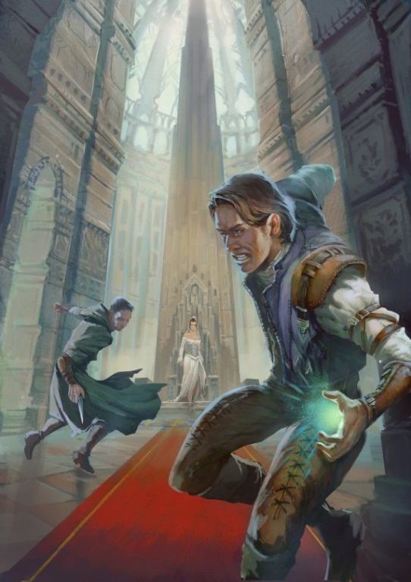

Hydra Publications
$14.99 trade paperback | $3.99 e-format
ISBN-13: 978-0615679747
December 1, 2012
Genre: Fantasy
Planned Media: Print/E-book
Distributed to the trade by Ingram Book Company

"We came to stop a war before it came to Cercia. And it seems the war has come to us."

Responsibility and patriotism spur Cercia's new leader, Quentin, to protect his beloved country at all costs and he assigns Asahel and Felix to serve as ambassadors and secret agents to Anjdur. Their journey quickly turns awry and Asahel and Felix barely escape a devastating shipwreck, walk a tightrope
of political tension, and rescue an empress before they learn they must face an enemy closer to them than they thought.

Will they be able to uncover an assassin's plot before it's too late? Will Asahel be able to unearth a secret that is vital to their mission? Will Cercia survive its own revolution? In The Jealousy Glass, Perkins boldly continues a series of unforgettable characters and events that will leave you begging for more.

Hydra Publications novels@hydrapublications.com
337 Clifty Drive hydrapublications.com | 812.574.4113
Madison, IN 47250

Contact: Hydra Publications, Marketing Director
marketing@hydrapublications.com

about the author

Gwen Perkins has always regarded the deep rainforest of the Olympic Peninsula the one place that she feels most at home. Gwen grew up in small towns across the Pacific Northwest, going to slug races and strawberry festivals when she wasn't scribbling on any scrap of paper she could come by. She boasts the dubious distinction of going to a public school with only eight students, learning Irish sea chanteys from a man who sang with the Clancy Brothers, and catching tadpoles during classes.

Her adult life is generally just about as much fun.

She lives in the City of Destiny (better known as Tacoma, Washington) with her three children, Amaranth, Nynaeve, and Oisin. Her hobbies include wandering beaches, baking pies and lampworking, or creating glass beads. In between all of this, Gwen has written two novels in the Artifacts of Empire series: The Universal Mirror and The Jealousy Glass.

She is presently at work on the third novel in the Artifacts of Empire series as well as a Great Depression-inspired fantasy novel, The Unwilling.

High-resolution press-ready files are available upon request for media use.

Hydra Publications novels@hydrapublications.com
337 Clifty Drive hydrapublications.com | 812.574.4113
Madison, IN 47250

Contact: Hydra Publications, Marketing Director
marketing@hydrapublications.com

about the press

Publisher Frank Hall states that "more people are writing, more books are selling, and more people are reading." This desire to meet the growing needs of readers and a lifelong dedication to literature inspired Frank to start a small press in 2010. Hydra Publications is a small press dedicated to producing quality fiction titles. Hydra releases between six to fifteen novels a year in a multitude of genres. Our titles are available internationally in both print and e-editions.

To receive distribution materials or learn more about our publications, contact:
Frank Hall
Owner
Hydra Publications
337 Clifty Drive
Madison, IN 47250
812.574.4113
frank@hydrapublications.com

To speak with the author directly about interviews, book signings, or other appearances, contact:
Gwen Perkins
Author
graeae@gmail.com
Skype: gwenperkins

More information is located on the publisher's website: http://hydrapublications.com

